Educational PTSD Game

## Table of Contents

|  |  |
| --- | --- |
| Executive Summary |  |
| Project Overview  Educational Component |  |
| User Stories |  |
| Planned Levels and Functionality Table  Final List of Included Levels |  |
| Obstacles  Prototype Requirements |  |
| Software |  |
|  |  |

## Executive Summary

The purpose of this game is to demonstrate to players in an interactive, safe environment what the symptoms of PTSD are and how they affect an individual. While this is an educational game, our main audience is adolescents who have experienced trauma. These users after playing and interacting with the levels are better able to understand how they are personally affected by the symptoms. We want these individuals to be able to understand what the symptoms are so they can better manage their responses after traumatic event exposure.

We plan to have physicians and doctors made aware of this interactive environment to inform through gameplay about the signs and symptoms of PTSD as a future goal. We hope to provide better patient-centered care with mutual understanding between patients and physicians.

## Project Overview

The main environment this project needs to provide is one that does not produce any realistic events, figures, or images. **The project is to do more good than harm, and our team is being cautious with how we represent the player and symptoms as mechanics.** We do not want the player to feel too attached to their avatar on the screen. This is because we want the player to feel comfortable engaging in an environment that represents them abstractly. The player should have no fear of facing any visual or auditory representation that triggers discomfort.

The game will loosely follow the structure of the CPSS, or Child PTSD Symptom Scale. The game’s framework will be in a similar fashion to the 17 questions the CPSS contains. Meaning, approximately every level will be centered around 1-2 questions depending on the team’s decisions. For example, the first prompt in the CPSS is to *“Type the first word that comes to your mind when you hear the words* ***upsetting thoughts/images.****”* A level idea would be to include the word the user inputs on a monster-character and the objective is to chase that monster away.

Initial Prototype Level:

The initial prototype is an experimental piece by Katie to get used to developing for mobile. One mobile device control is the *accelerometer.* The accelerometer is a device of a phone that is able to detect orientation. When the phone is tilted left/right, forward/back, the game is able to move the player who is represented by a simple 2D circle. The objective of the prototype is to avoid the ghost enemies that appear on the sides of the game. Although no programmed end/win state, the player is able to maneuver around the map and tilt the phone to avoid the ghosts!

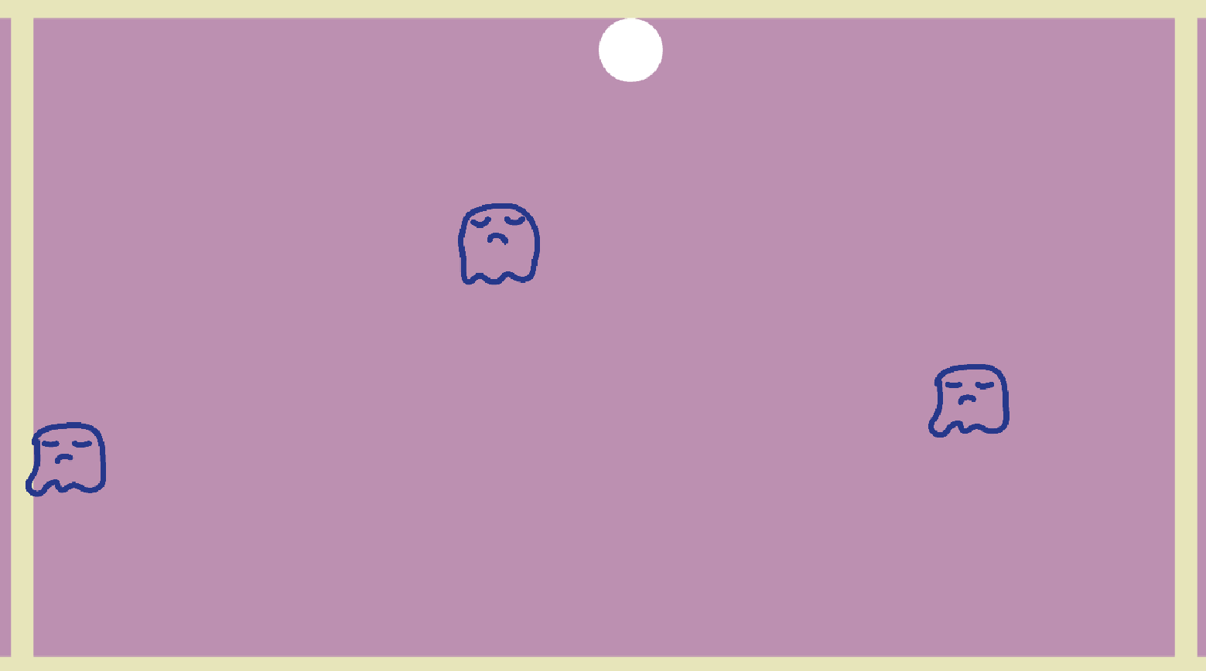

There is no set color scheme set for the prototype or game as a whole yet. Here are the items on the screen based on their color:

white: the player. the player is able to move all around the screen by tilting their device.

yellow: boundaries. For now, the screen boundaries are visible so when developing the prototype it was easier to see where they were.

dark blue: the ghosties/enemies. the enemies in the prototype only spawn in

Gameplay: the player tilts the screen to avoid the ghost enemies!

The player is designed to move the white circle around the screen by tilting their phone in 4 directions. The app is designed to be held horizontally, with the screen facing about 30 degrees upward to the user’s face. 

As seen in this image, the screen is slightly tilted upwards. This would be the natural ‘resting’ position of the user. The prototype jumps right in and barely moves when the user is in this resting position. When the user begins to tilt the phone *away* from them, the white ball moves to the top of the screen. All directions of the white ball move according to how the user tilts the screen.

## Educational Component

The overall gameplay will educate players on how the words associated with *“upsetting thoughts/images,” “nightmares,” “recurring events”* (to name a few questions from the Capstone document) affect an individual. For example, one mini-game idea would be to have the player chase away a monster, with the word input on the monster. Alternatively, the player could cover up the word associated with “*upsetting thoughts/images”* with clouds, or protect an image of a brain by shielding any words that come at it (as noted on page 9 of the Capstone document). The goal is to educate adolescent players on the symptoms of PTSD and help adolescents recognize how they respond after experiencing a traumatic event. We want adolescents who have had exposure to trauma to know the signs and symptoms that way they can better manage and explain their responses. Physicians as well would be able to learn about the signs and symptoms and be able to have a dialogue with their patients, thus resulting in better patient-centered care.

The game is meant to illustrate in an abstract way the possible effects of trauma with guided level questions and fun gameplay. While the game will take on a more serious role, the mechanics and actual gameplay will be made to be fun, pleasant, and offer enough distance from specific imagery, subjects, and the like so player’s are not distraught or uncomfortable. Each level/question segment will have a unique question that stems from the CPSS, a child PTSD questionnaire.

## User Stories

User stories are a way to write the requirements of software from the perspective of the person who is using it. By writing out the requirements in a statement form from a user’s perspective, it helps keep the focus on the software’s requirements. Here is a list of user stories from the perspective of its users:

1. As an adolescent, I can play this game and feel calm/at peace.
2. As an adolescent, I can input a word according to the prompt, and also have the option to skip.
3. As an adolescent, playing this game will show me how trauma impacts the mind and body.
4. As an adolescent, the game is fun to play and has replay-ability (high score based mostly)
5. As an adolescent *who has experienced trauma,* I can confidently identify my responses after seeing how trauma affects the body and mind.
6. As an adolescent *who has experienced trauma,* I can comfortably discuss with a certified physician on my experiences and responses.

Overall, regardless of if the adolescent has experienced trauma or not, the game will be educational, fun, and will not provide any specific imagery, and be a calming environment meant to safely educate.

## Planned Levels and Functionality Table

When I planned the new design, the image I have for the avatar that the player controls is a white ball. The enemies are angry scribbles with the word inputted attached to them. **Other non-player balls in the levels are meant to represent friends/support.**

* Branching off of the friends/support NPCs, I think it would be great to add them as ‘cheerleaders’ in the game to encourage the player as well as offer assistance in game. Their assistance could be reducing the number of enemies on screen, slowing time down, speeding up the player, giving them invincibility etc. Something that reminds the player that they are not alone.

|  |  |  |
| --- | --- | --- |
| Level Name/Number | Guided CPSS Question | Mini-Game Idea and Description |
| Level 1 | Type in the first word that comes to your mind when you hear the words **upsetting thoughts/images.**  Having upsetting thoughts or images about the event that came into your head when you didn’t want them to | i. Chase away the monster with the word on its body  ii. OR use a happy cloud to cover up the thought bubbles with the word  iii. OR use a shield to protect a cartoon brain and chase the thought bubbles with the word that want to go toward the brain away  --------------------  Player can chase away enemies from a central target. This would combine the 1st and 3rd ideas! There could be a central ‘tower, ’ or brain the player would have to defend. The player could then chase away monsters that come too close (with the word on them). The player would be able to tilt the phone to move, then maybe tap a button on the screen to ‘spook’ or force the monsters away! Just being near the monsters isn’t good enough, they need that extra shove from the player!  I think this combined idea is great and the ‘tower’ (brain) can be used in subsequent stages as well.  **Level 1 is about avoiding the word on the screen from all sides for a certain amount of time.** |
| Level 2 | Type in the first word that comes to your mind when you hear the word **nightmares**  Having bad dreams or nightmares | * there may be an opportunity for a transition, to make gameplay based on waves of enemies. add layers of difficulty to the tower defense-ish first level, then because the player now associates the word with nightmares, the player has a limited field of view as the level has grown dark.   This is great! I am wondering if we can still keep the brain in the center and have enemies coming from all sides and bring a dark circle with them. This means that the screen will basically turn dark from outside in and clears up bit by bit as players defeat each enemy (by using the same tap a button function in the previous level). If the enemies reach brain too many times (leaving player with no health point), then the level will just restart.  However, the current design sounds good too, so if it is difficult to change, then we should use the current design  **Level 2 is about avoiding the word on the screen from all sides for a certain amount of time AND have their field of view limited in that darkened space.** |
| Level 3 | Type in the first word that comes to your mind when you hear the words **recurring events/reexperiencing**  Acting or feeling as if the event was happening again (hearing something or seeing a picture about it and feeling as if I am there again) | * as a stand-alone mini-game, the player could be encountered with a never-ending ‘time loop’, meaning the section they are in will allow them to move forward but they will loop back to the start. The theme of the mini-game would have to do with repetition or deja vu, but in a way where it will not stress the player out. * One way to introduce this is to have the player loop in a room with 4 portals at the North, South, East, and West. Any portal brings them back into the same room, just through another portal. With the waves possibly still active, the player will have to push a colored circle that corresponds to a portal color inside of it to destroy it. Once all portals are destroyed the player moves onto the next level   I am wondering if we are able to create identical rooms so that when the player rolls up/down/left/right of the screen, it will feel like the player has entered the same room (representing recurrence). The wave of enemies should still be active while the player is trying to hit the colored circles (or we can make the brain look subtly different and have the player hit that part of the brain). We can also have a count of how many circles the player has hit, so the player knows how many circles left. |
| Level 4 | Type in the first word that comes to your mind when you hear the words **feeling upset**  Feeling upset when you think about it or hear about the event (for example, feeling scared, angry, sad, guilty, etc) | * I’d like to make a ‘feeling down’ themed level where the player has to avoid being ‘down’, so they have to go higher up in the level. This could be a jump game where you have to keep moving up the levels using the platforms and avoid enemies.   (doodle jump game)   * The player will have to avoid the word otherwise they will fall a bit lower in the stage. The player has to jump to the top as fast as they can as the camera pans up.   I think this is a good idea. I think it depicts feeling upset and shows that players should always look up.   * Maybe a better way of representing this would to have a greyscale level as well? Because we can’t really add in specific visuals, I’d like to be able to change the color scheme of certain levels to fit the mood and theme and level |
| Level 5 | Type in the first word that comes to your mind when you hear the words **breaking out into a sweat and heart beating fast**  Having feelings in your body when you think about or hear about the event (for example, breaking out into a sweat, heart beating fast) | * The transition from the last stage to this level would be the player would pause on screen a second and you would hear the heartbeat, and see some sweat from the avatar. * There will be a cartoon heart that is sweating and moving really fast. The players need to collect ice cubes on the screen and place them near it/on it to slow the heart down.   1. This is to simulate a vagal maneuver   * the player would have to bounce cubes onto the heart that fall on screen and avoid the word as it falls as well.   I think the transition is great. I feel that for this level, we can keep the sweat going and have the player collect ice cubes around the screen while avoiding/destroying enemies. However, the ball that the player control will stop on its own if it moved too much and too fast. Resting for 3s or collecting the ice cubes will help it regain mobility. The level should end when all the ice cubes are collected. |
| Level 6 | Type in the first word that comes to your mind when you hear the words **trying not to think about, talk about, or have feelings about an event**  Trying not to think about, talk about, or have feelings about the event | * once the last mini-game finishes, the heart will be content and happy! The camera pans back up to show the player in a new area. the player will be trying to relax and watch TV * in this level, the player will be trying to tune a tv (a really old school one with nobs and buttons) to a channel that does not display the word they typed in. the player will have to turn some nobs and tap the antenna of the TV to get the channels to show clearly. The word will sometimes be on the channels and the player quickly needs to change them.   Does this teach adolescents to avoid the problem instead of confronting it??  I think this is a good idea, but like you said, it could potentially teach them to avoid the problem. I am thinking we could have the player automatically bounce away from enemies whenever player gets close to them, so the player can’t just destroy enemies like in level 1. The goal is still to destroy all enemies, so we can place two other balls (one on each side of the screen), and the player can only destroy the enemies when the player is close to the two other balls.  **-I am hoping to simulate seeking help and friend support here.** |
| Level 7 | Type in the first word that comes to your mind when you hear the words **trying to avoid activities, people, or places that remind you of an event**  Trying to avoid activities, people, or places that remind you of the traumatic event | * the player could be using a map to navigate around the stage and be constantly encouraged and praised for exploring/trying new things? This could be with dialogue from NPCs (non-playable characters, and they will just be shapes)   I am thinking this could be similar to level 6, except this time the player doesn’t move away from the enemies, but the player moves away from the two other balls. The goal here is still trying to defeat all enemies, but the player will have to maneuver in such a way that allows the enemy to be right between the player and one of the two other balls in order to destroy the enemy. With each enemy defeat, it gets easier to get closer to the two other balls. |
| Level 8 | Type in the first word that comes to your mind when you hear the words **not being able to remember an important part of an event**  Not being able to remember an important part of the upsetting event | For this level, we can use a similar setup to level 3, meaning that we can have the player roll up/down/left/right into different rooms. Initially, the ball that the player controls will have some faded parts, representing the lost memories. Each room will have one of the faded parts and the player will have to collect them while avoiding/destroying enemies.  Maybe the player will have to connect puzzle pieces and get them to touch each other. The puzzle will have 4 pieces, and there will be 3 rooms. Each room has 3 portals that go to one of the other rooms, just to make things a little confusing. The player has to make the pieces touch another in order to complete a part of the puzzle. 2 pieces collide and reappear outside the circle rooms to show the player is putting pieces together. |
| Level 9 | Type in the first word that comes to your mind when you hear the words **having much less interest or doing things you used to do**  Having much less interest or doing things you used to do | To depict a decrease in interest, I feel that we can make the player’s speed and strength of attack much lower than the previous levels. Other balls will show up with time. With the collection of other balls, speed and strength will both slowly go up. Goal is still destroying enemies (which is a thing that the player “used to do”). |
| Level 10 | Type in the first word that comes to your mind when you hear the words **not feeling close to people around you**  Not feeling close to people around you | * Since level 3 was modified from the original idea, this idea will have to be modified as well. * The rooms are further divided, and color scheme is different to make sure the player knows this level is not exactly the same. The player has to move 4 different orbs into their corresponding portals. Maybe after the player pushes each orb into their corresponding portal two times, that orb will disappear meaning the player has completed that orb task. * I don’t think the level would be challenging if the player is able to destroy the word in this level. If it’s by tapping the word, this level may be too easy since all the player would have to do is tap all over the screen as they roll the ball. But on the other hand, combining the tap feature with the rolling one could be tricky and prove a good challenge. This will be tested.   Again, I am thinking to use a similar setup as level 3. There will be 4 balls in each room (after rolling up/down/left/right). The player will have to bring all 4 balls back to the center room to clear the level. Player still has the ability to destroy enemies and each time the player gets touched by the enemy, the health point drops and the player returns to the center room. However, the 4 balls do not go back to its original position, and stay at wherever the player leaves them. |
| Level 11 | Type in the first word that comes to your mind when you hear the words **not being able to have strong feelings (unable to cry or feel happy)**  Not being able to have strong feelings (for example, being unable to cry or unable to feel happy) | For this level, I think we can have emoticons (or just the smile portion, laugh portion and tear portion of the emoticons) scattered around the screen. They will be guarded by stationary enemies and player will have to tap the button to blow them away enough, so the player can sneak in and collect the emoticon. There should be free moving enemies as well. The main goal is not to destroy all enemies but to collect the emoticons.   * I’m thinking the friends and support NPCs can give the player items to do these things. One friend can give the player a big fan, and with that new item, the player can blow away enemies! |
| Level 12 | Type in the first word that comes to your mind when you hear the words **feeling as if your future plans or hopes will not come true**  Feeling as if your future plans or hopes will not come true (for example, you will not have a job or getting married or having kids) | For this level, I am thinking we can start the player with a reduced health point in order to depict future plans less likely to come true. As the player destroy enough enemies or collect a ball (friend), the player will regain health points back one at a time. The level should end when the player reached the full 5 health points. |
| Level 13 | Type in the first word that comes to your mind when you hear the words **having trouble falling or staying asleep**  Having trouble falling or staying asleep | i. A humanoid avatar trying to sleep on a log, but cannot fall asleep, so the player needs to roll the avatar onto a bed, turn off music, and move all the distractions (i.e. phone, computer) off the bed before the avatar can fall asleep 1. Can let them try to figure out what needs to be done instead of giving them instructions a. Give them hints after 5 seconds if they are unable to figure out what needs to be done  For this level, I originally have the above idea. However, in order to make things easier and flow better, I think we can have the player on the log, trying to fall asleep. The player can help the ball avatar go to sleep by trying to balance the ball avatar on the log and let it stay there for a certain amount of time. However, there will be enemies that try to come and tip off the balance, so the player will need to tap on those enemies and destroy them before they get to the ball avatar. |
| Level 14 | Type in the first word that comes to your mind when you hear the words **feeling irritable or having fits of anger**  Feeling irritable or having fits of anger | For this level, I am thinking to have the player roll from left to right of the screen towards a goal. The player will avoid enemies as the player moves the avatar towards the goal. When the player gets hit by enemies, the health point decreases and the ball turns redder and moves faster. There will be sporadic wind symbol or another ball that appear for the player to collect to help decrease the speed/redness. |
| Level 15 | Type in the first word that comes to your mind when you hear the words **having trouble concentrating**  Having trouble concentrating (for example, losing track of a story on the television, forgetting what you read, not paying attention in class) | i. The avatar on screen will be trying to make a to-do list, but keeps on stopping, so the player needs to remove distractors (such as music, phone, etc.) 1. Can let them try to figure out what needs to be removed instead of giving them instructions on which ones to remove a. Give them hints after 5 seconds if they are unable to figure out which ones need to be removed  Again, the above is the original plan, but I am thinking to change it to the following for a better flow:  Similar to level 14, the ball avatar is rolling from left to right towards a goal. The ball avatar will want to deviate on its own whenever enemies show up (so the enemies are distracting the avatar from concentrating on what it is doing). Again, the player has to destroy the enemies by tapping on them to keep ball on track towards goal. |
| Level 16 | Type in the first word that comes to your mind when you hear the words **being overly careful**  Being overly careful (for example, checking to see who is around you and what is around you) | Similar setup to level 14, the ball avatar is rolling from left to right towards a goal. However, this time the enemies form blocks of obstacles, leaving a narrow path for the player to pass, depicting the idea that the player is being very careful. |
| Level 17 | Type in the first word that comes to your mind when you hear the words **being jumpy or easily startled**  Being jumpy or easily startled (for example, when someone walks up behind you) | Again, similar to level 16, the ball avatar should be rolling towards a goal and the enemies still form blocks of obstacles. However, this time, the player will not be able to roll between the blocks. The player will have to jump over the blocks. The ball avatar will be extra jumpy if the player taps twice on the jump button. Some enemy blocks can be slightly faded, meaning that the player can just roll right through them. This is meant to depict the idea that the player can learn not to jump at all enemy blocks even though they may look similar. |

I also feel that we don’t have to conform to the order that the questions were asked in the CPSS questionnaire. With the current design, I think the game might flow better with the following order:

Q4 -> Q5 -> Q1 -> Q2 -> Q3 -> Q8 -> Q12 -> Q10 ->Q7 -> Q6 -> Q11 -> Q9 -> Q13-17

## Final List of Included Levels (updated 10/5/2020)

Our team decided to condense the number of levels for the finished game to 10 rather than the above 17. The due date for the game is November 20th, 2020.

The Child PTSD Symptom Scale is designed to cover 3 categories of PTSD symptoms which are the patient diving into or re-experiencing, a state where the patient moves into avoidance, and lastly where the patient experiences hyperarousal. As explained by Winnie, questions 1-5 cover re-experiencing the event, 6-12 pertain to avoidance, and 13-17 are about hyperarousal. Therefore, the best course of action would be to include an equal amount of the questions from each category. The following list is what will be included for the game:

1. Upsetting thoughts/images

2. Nightmares

3. Recurring events/reexperiencing

4. Feeling upset

---------------------

7. Trying to avoid activities people, or places that remind you of an event

8. Not being able to remember an important part of an event

10. Not feeling close to people around you

---------------------

14. Feeling irritable or having fits of anger

16. Being overly careful

17. Being jumpy or easily startled

## Obstacles

The primary obstacles to be faced are program features and ensuring the user has fun in a comfortable environment while still learning about the symptoms of PTSD. So far, the ideas waterfall off of each other meaning after each level, it transitions into the next guided question with ease, then starts a new mini-game. The art and gameplay I am trying to keep not so different from the previous level so there is a clear gameplay narrative. Also programming a system that includes all the guided questions, mini-game conditions and pause feature would require planning ahead. UML diagrams for the algorithms and data structures will ensure the game will be developed with minimal bugs, and run smoothly!

A recent obstacle involves the actual capability of my laptop computer and touchscreen keyboard. My laptop is beginning to act up and freeze when running Unity and testing the game. The touchscreen keyboard does not appear on iOS device when using Unity Remote. Other potential obstacles would be how objects in screen interact with each other and making sure unused objects in the scene are deleted, and making transitions to new mini-game levels clear.

## Prototype Requirements

The prototype refers to the end state of the programmed levels. There does not need to be an end state, the prototype will be a better version of an MVP. Mostly concentrated on the gameplay and mechanics, the prototype will not have fancy or completed visuals or art assets. The artwork will mostly be placeholder assets but have a cohesive color scheme. The game will be a calm and fun experience that educates. Here is a shortlist of overall development requirements the prototype will need to meet:

1. 5 levels finished with their own mechanics/additions to previous levels.
2. code system in place to control the player, enemies, and end-states.
3. the player will be able to type in input using the keyboard
4. levels will have a soft color scheme

## 

## Software

The main software we will be using is the Unity engine for the development of the game and Adobe Photoshop/Illustrator for any art assets. In addition, Visual Studio will be the primary method of programming with the help of some Unity assets like Lean Tween (potentially) to help add some small animation and movement details to the UI.

## User Interface Design

1. *Navigation Map for Levels*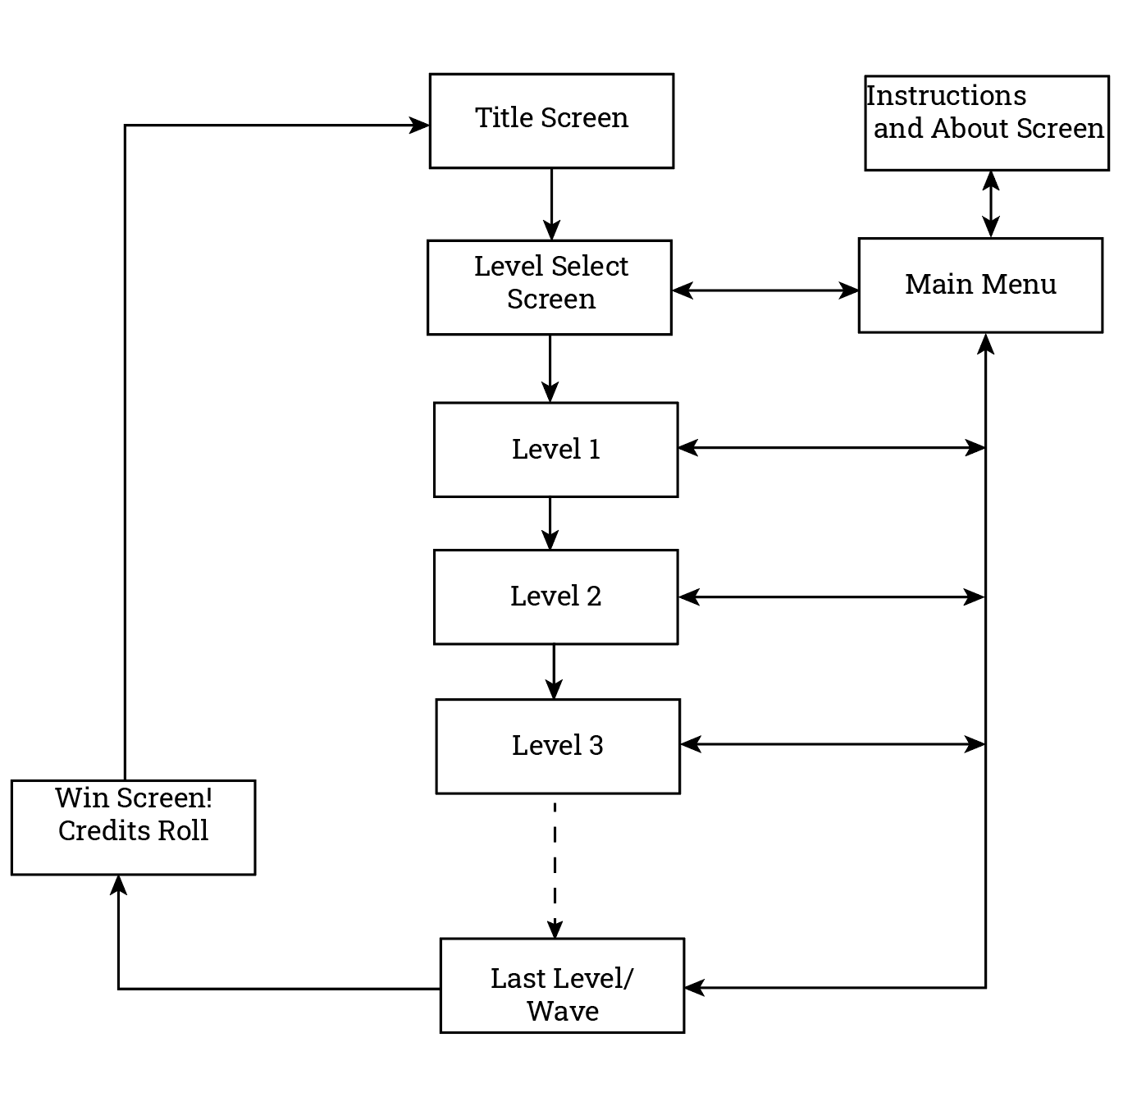

The player will be able to open the main menu screen from any level to check controls, and read a bit about the game. Later on in development, the user would be able to save which level/wave they are on.

The Title Screen is just the splash screen with the game’s title, and you press start to begin.

Level Selection allows users to jump back to any level they have saved in. When selecting a level the player jumps back in, starting at the beginning of the level and will have to re-enter their word for the guided question from the CPSS.

Instructions and About screen includes the instructions to play the game and the purpose of the game.

Once the player has completed all levels they will be congratulated with a win screen where the credits will roll.

1. *Wireframes/Mock Ups*

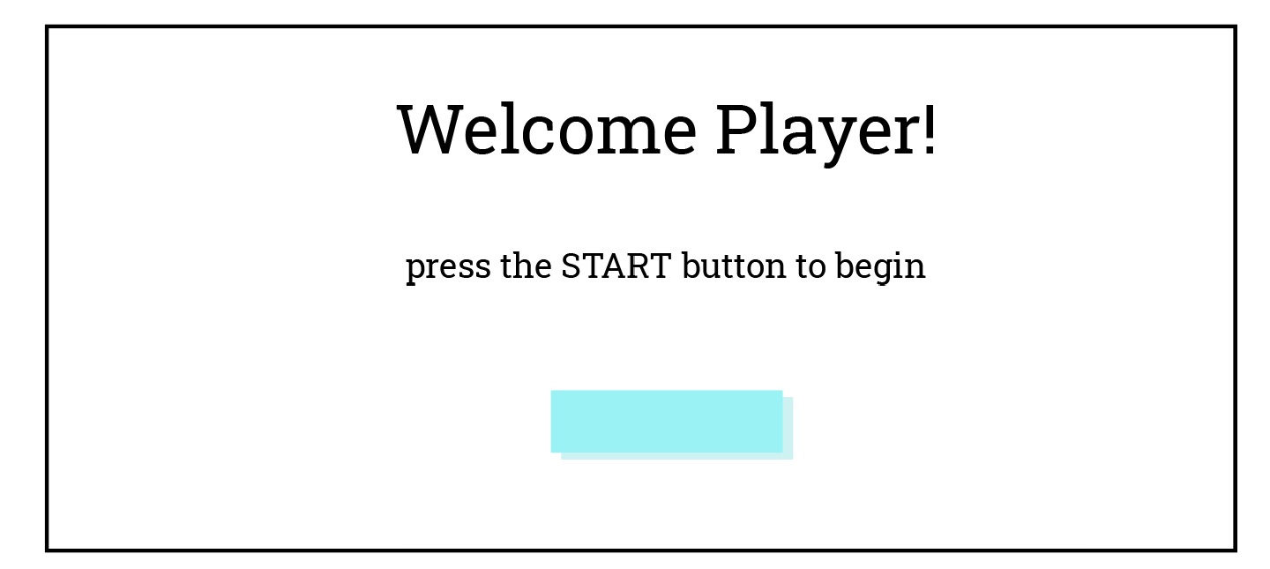

The Title Screen here will include the title of the game and welcome text. The light blue rectangles are clickable. The player will have to click the button to start!

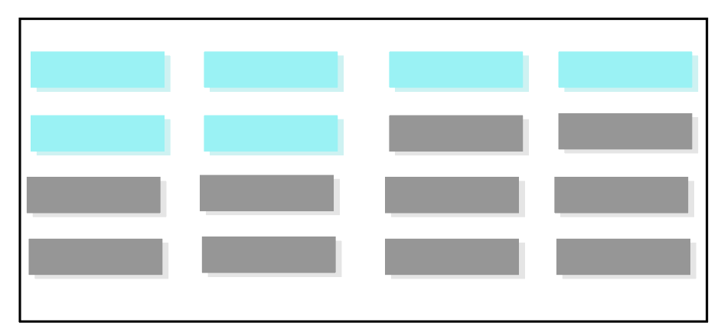

In the level select screen the player will only be able to access the levels they have already completed or saved in. They greyed out rectangles represent locked levels the player has yet to complete or get to.

The levels will all contain a main menu button on the top left and health blips on the right. As the player comes into contact the words on the angry scribbles they will lose health blips. Of course the player will be in different levels that look different, so this level is the generic one to show one type of enemy that represents how the word will be in the game.

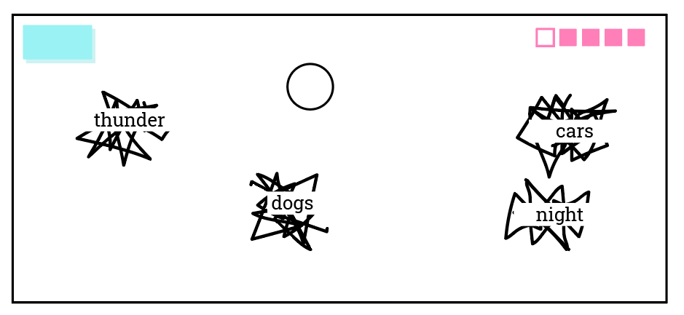In this sample level, the player can be protecting a cartoon brain (one of the level ideas) and will have to bounce the angry scribbles with words away! The scribbles will appear all around the screen converging to the center, and the player will have to maneuver around to prevent any damage coming to the brain.

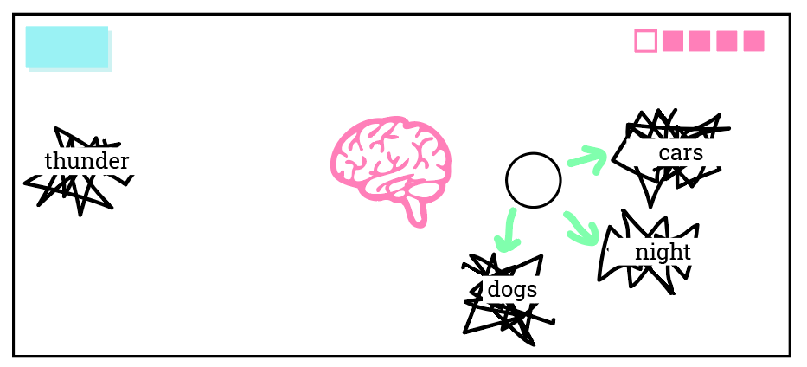

## Game Flow

General Flowchart for Level Progression (subject to change):

1. *The Flow of the Game (simplified)*

As the gameplay stands now, there are waves of enemies and each layer of difficulty adds onto the last. But with levels that are so different than others, there will need to be transitions made between them, and clear ends to the levels.

The transition may be asking the CPSS question prompting the player to type in a word, then fading into the new level. Once completing a level, the enemies stop coming in, the screen is cleared, and text on screen appears, “Level (x) Completed!”

1. *Enemies*

The enemies in the game are the word the player types in, attached to something abstract. Since we don’t want to show any imagery that would trigger a response, the less specific stimulus the better. Representing the words with angry scribbles would allow there to be an animation where the scribble would jitter and move, and let the player know that the scribbles are not friends! In some levels, the scribbles would need to be avoided, chased, bounced away, or other. This is a basic representation of how one enemy (of maybe a couple more, but that’s to be determined) would look in the game.

Going off the wave idea, if enemies come in waves, every so often the player would be prompted with a CPSS guided question to enter a new word. Then with each question, the enemies will get faster and the player will have new abilities and challenges each level. For instance, the first wave has the normal scribble enemies, and you have to avoid them. They only appear on one side of the screen. Then the second wave will have more enemies from 2 sides, and they get a bit faster. When I tested how many sides became difficult, having enemies appear on two sides was really easy. Then with the third wave, players will have limited visibility - everything will be in ‘black-out mode’ where the 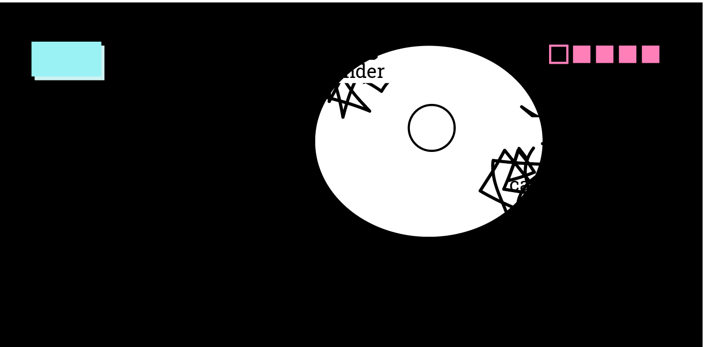player has a small spot light on them.

It would look something like this. A spotlight on the player with enemies barely visible from the sides.

## Gameplay Mechanics

The mechanics of each level or ‘wave’ will be slightly different and rely on the capabilities of a mobile device (primarily iOS devices). There are a few key devices that are built into a mobile device that will be used throughout the game:

**Accelerometer:** This device stores where and how the phone is angled. As seen in the diagram below, there are 3 axis’ that tell the device how it is being tilted and where in 3D space it is in. Axis’ X, Y and Z are used in the game’s code to allow the player to move in 2D space.

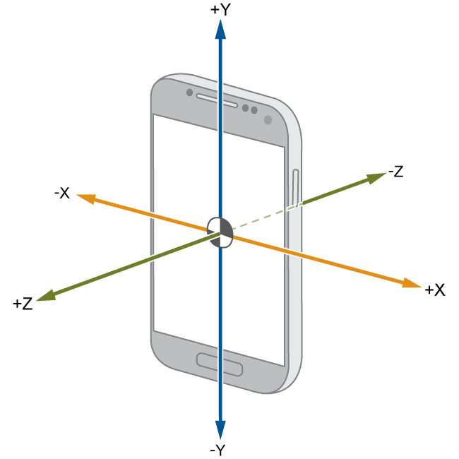

**TouchScreenKeyboard:** the game would allow the user to input a word they associate with one of the questions in the Child PTSD Symptom Scale; ex: “Type in the first word that comes to your mind when you hear the words having trouble concentrating”.

**While Unity does have documentation offering support for GUI TypeFields (where you select a box and can type your input) there are no online examples or APIs that offer guidance to how I have my Unity Remote 5 application on my iOS set up. I am still searching for documentation and tutorials for help. Unity Remote 5 allows me to use my laptop, running Windows 10, to connect to my iPhone X with a USB and emulate the game on the phone. Many of the forums I’ve seen offer solutions for Android developers but none for iOS. 

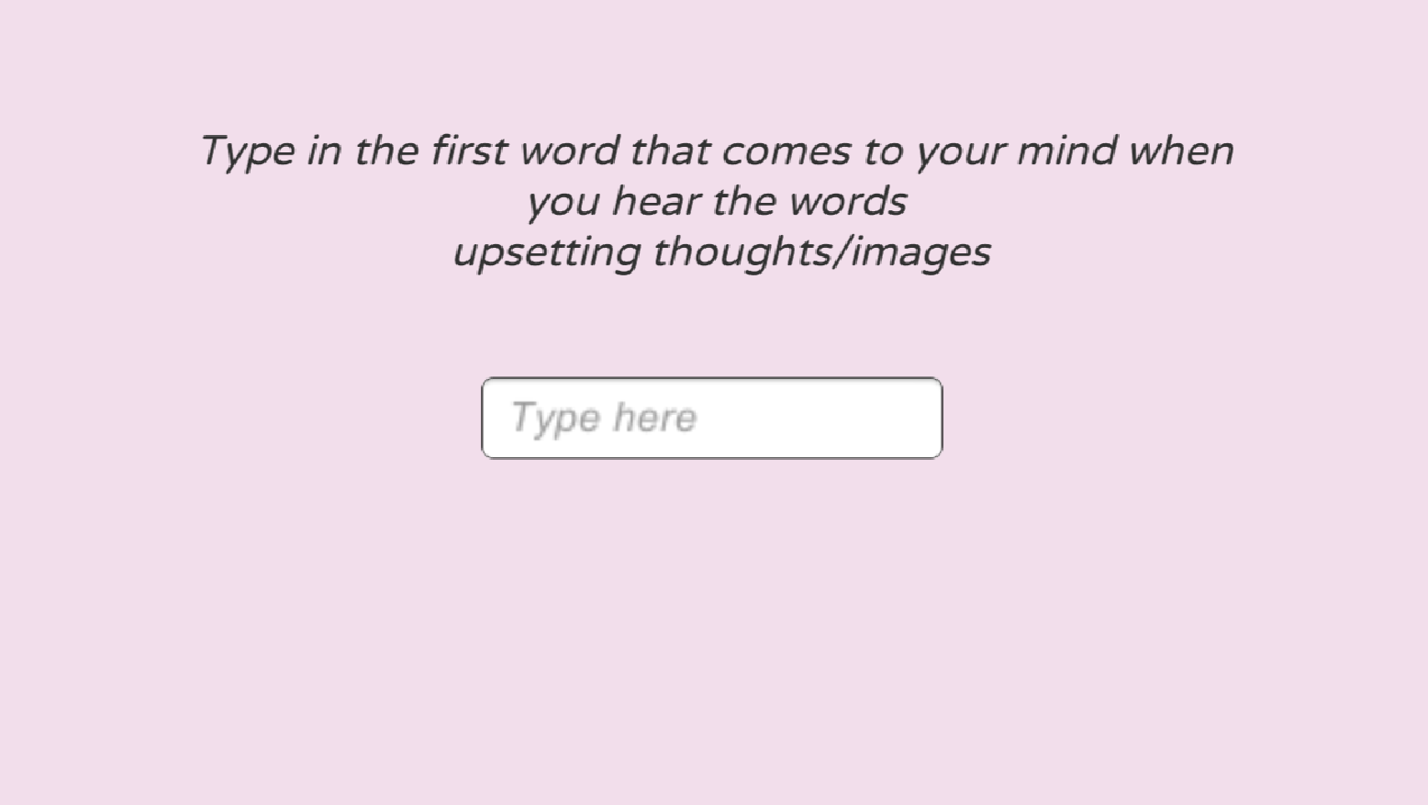TouchscreenKeyboard Input test screen 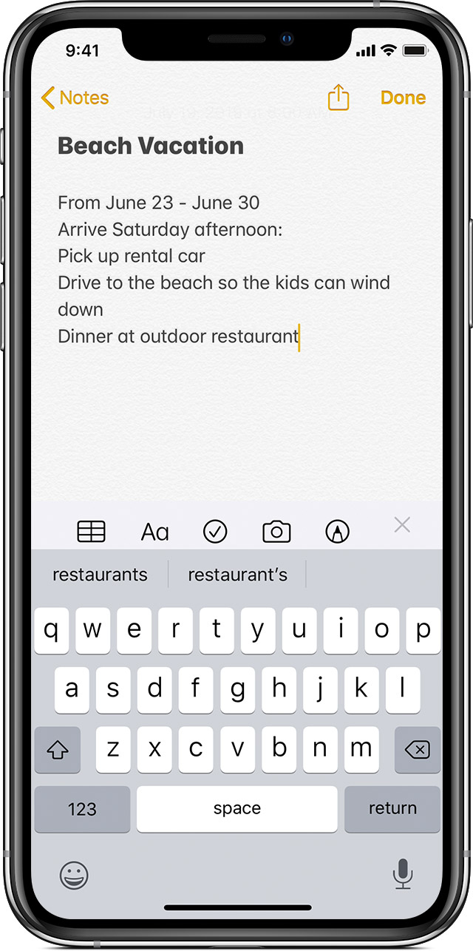keyboard

What is supposed to happen when you click the type field that says “Type here” is the mobile keyboard of the iOS device should pop up and allow the user to type in a word. The problem is the touchscreen keyboard doesn’t actually appear on my iPhone when I’m using Unity Remote. A few Android sources have said that this is because the ‘TouchScreenKeyboard.Open("", TouchScreenKeyboardType.Default, false, false, true);’ opens the default keyboard of the device, but since the Remote app just emulates the game it isn’t quite connected to the device’s keyboard itself. The keyboard command does not work in the Unity Editor using Remote. But the application will work when building the app to the device itself. However, because building to iOS requires a Mac which I do not have, I will build to Android and test on my sister’s Android phone to see if the keyboard pops up.

**Touch Controls:** mobile devices can easily detect touch input. Touch input can be used to activate abilities, move objects, or interact with them, or interact with any UI buttons like a Main Menu button.

Resources:

1. Android TouchscreenKeyboard does not show up in Unity Remote - <https://stackoverflow.com/questions/36046136/unity-android-touchscreenkeyboard-does-not-appear>
2. Unity Manual, TouchScreenKeyboard - <https://docs.unity3d.com/2018.4/Documentation/ScriptReference/TouchScreenKeyboard.html>
3. Unity Manual, TouchScreenKeyboard OPEN - <https://docs.unity3d.com/2018.4/Documentation/ScriptReference/TouchScreenKeyboard.Open.html>
4. Unity Scripting, InputField - <https://docs.unity3d.com/2019.1/Documentation/ScriptReference/UI.InputField.html>
5. Unity Manual, InputField - <http://stalhandske.dk/UnityDocs/Manual/script-InputField.html>
6. Unity Manual, Mobile Keyboard - <https://docs.unity3d.com/Manual/MobileKeyboard.html>
7. DIY UI Keyboard - <https://www.youtube.com/watch?v=8324jUUYbKk>

I will most likely have to create a GUI keyboard like in resource #7 if the Android build does not display the mobile keyboard. If the Android build on the Android phone *does work and display the keyboard,* I can most likely assume it will work for iOS devices as well.

1. Iterate over an array, foreach loop: <https://stuartspixelgames.com/2017/03/27/how-to-do-for-each-loops-in-unity-c/>

## Conclusion

to be filled out when the game is approaching or is completed.